**Facial Datasets**

Facial expression datasets have two types of creation of images: posed expressions images and spontaneous expressions images datasets. Researchers acquired facial images in three ways such as peak expression images only, image sequences portraying an emotion from neutral to its peak, and video clips with emotional annotations. The two widely used datasets are CK+ and JAFFE. The real-world facial databases are FER-2013, FERG-DB, SFEW2.0 (static facial expression in the wild), RAF-DB (real world affective face database) and Affect-net database. Sample images of basic facial expression are described in Table. 1 for each dataset

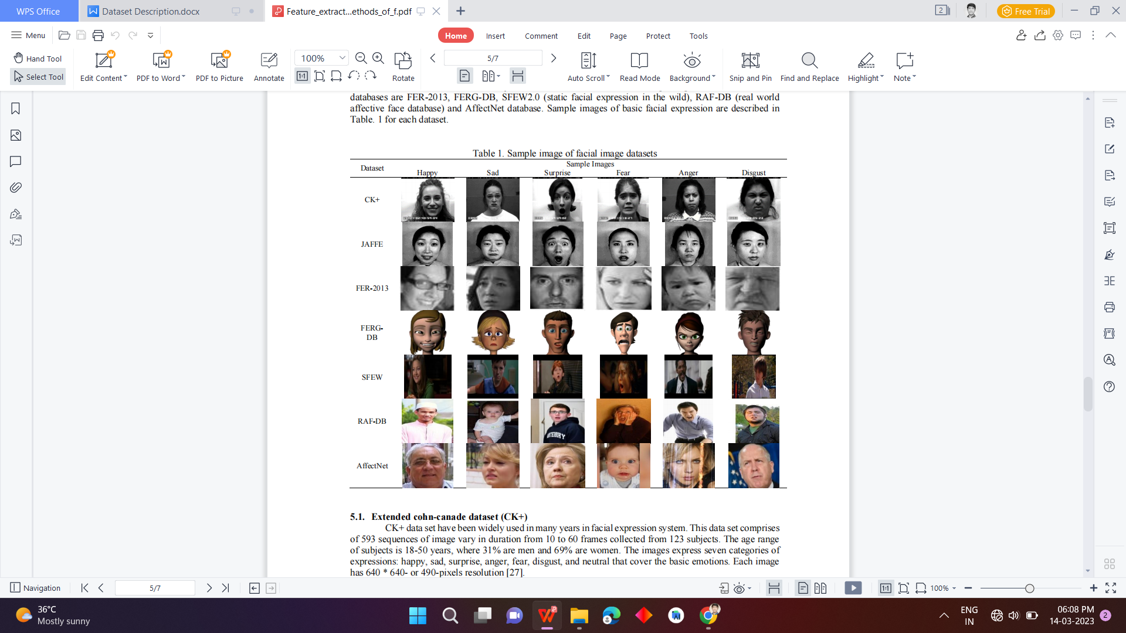

**Extended Cohn-Kanade dataset (CK+):-**

CK+ data set have been widely used in many years in facial expression system. This data set comprises

of 593 sequences of image vary in duration from 10 to 60 frames collected from 123 subjects. The age range of subjects is 18-50 years, where 31% are men and 69% are women. The images express seven categories of expressions: happy, sad, surprise, anger, fear, disgust, and neutral that cover the basic emotions. Each image has 640 * 640- or 490-pixels resolution

**Japanese female facial expression dataset (JAFFE):-**

JAFFE data set is also widely used in expression recognition of human emotion. This dataset consists of 213 images of 10 Japanese females including seven expressions: six basic (happy, surprise, sad,anger, fear and disgust) and neutral. Each image has the resolution of 256 * 256 pixels

**FER 2013 dataset:-**

FER-2013 data set contains 35,887 images that are labeled. The dataset is created in 2013 for learning focused on three challenges: the black box learning, the facial expression recognition challenges and the multi modal learning challenges. The images are 48 * 48 pixels grayscale of faces in seven expressions: six basic expression and neutral

**FERG-DB dataset:-**

FERG-DB stands for facial expression research group database that consists of face images of six stylized characters grouped into seven types of expressions: six basic expressions and neutral. The dataset includes 555767 images

**Static facial expression in the wild dataset (SFEW) :-**

The images in the SFEW are extracted from a temporal facial expressions database Acted Facial Expressions in the Wild (AFEW) which has been extracted from movies. The database contains 700 images that have been labeled into six basic expressions

**Real-world affective face database (RAF-DB):-**

RAF-DB database is a large-scale facial expression database that includes facial images downloaded from internet. The dataset is annotated seven-dimensional expression distribution vectors for each image

**Affect-net dataset:-**

Affect-Net is a largest database of facial expression in the real-world and contains more than 1,000,000 facial images downloaded from the internet search by six different languages with 1250 emotion related keywords. The database defined eleven categories of expression: six basic expressions, neutral, contempt, none, uncertain, and non-face

We are using FER 2013 for our project and all the information of the Fer 2013 Dataset is given below:-

FER2013 is a widely used benchmark dataset for facial emotion recognition research. It contains 35,887 grayscale images of faces that are labeled with one of the seven emotions: anger, disgust, fear, happiness, sadness, surprise, and neutral. The images were collected from the internet and manually annotated by human experts to ensure accuracy.

The FER2013 dataset is divided into three subsets: training, validation, and test. The training set contains 28,709 images, the validation set contains 3589 images, and the test set contains 3589 images. The dataset has an equal distribution of images for each emotion class, with approximately 5000 images for each class.

The images in the FER2013 dataset are cropped and aligned to ensure that the facial features are in consistent location and size across all images. The images are also preprocessed to remove noise and enhance contrast. Each image in the dataset has a resolution of 48x48 pixels.